**LAPORAN PRAKTIKUM**

**PEMROGRAMAN WEB LANJUT**

**S1-SISTEM INFORMASI**

**“ LAPORAN PRAKTIKUM MODUL 4”**



**Disusun Oleh :**

|  |  |
| --- | --- |
| **Nama** | **Teuku Irvan** |
| **NIM** | **24.62.0219** |
| **Dosen Pengampu** | **Deni Kurnianto Nugroho** |
| **Nama Koordinator Asisten** | **Latif Ardiansyah** |
| **Kelas** | **BCIS 24** |

**S1 – SISTEM INFORMASI**

**FAKULTAS ILMU KOMPUTER**

**UNIVERSITAS AMIKOM YOGYAKARTA**

**2025**

# <<MODUL 4>>

## << ARRAY AND FUNCTION>>

### Tujuan

Setelah praktikum ini, praktikan diharapkan dapat : (isi dengan tujuan pembelajaran)

### 1. Explaining the understanding of Array implementation

### 2. Explaining the understanding of Array commands

### 3. Explaining the understanding of the application of functions (Function)

### 4. Explaining the understanding of function commands (Function)Peralatan

(isi dengan peralatan dan software yang anda gunakan)

### Hasil dan Pembahasan

(isi dengan hasil dan pembahasan dari tugas anda, Pastikan screenshot jelas dan terbaca)

**COPY PASTE CODING TEMAN NILAI default = 3**

Anda boleh mengembangkan tampilannya, atau menambahkan identitas diri pada setiap file, namun inti dari script wajib tetap ada. Pastikan dijelaskan menggunakan Bahasa Indonesia yang baku dan sopan

1. Screenshot Script dan Output Bagian Latihan Praktikum
   1. Screenshot Script dan Output Latihan 4.4.1

Script .

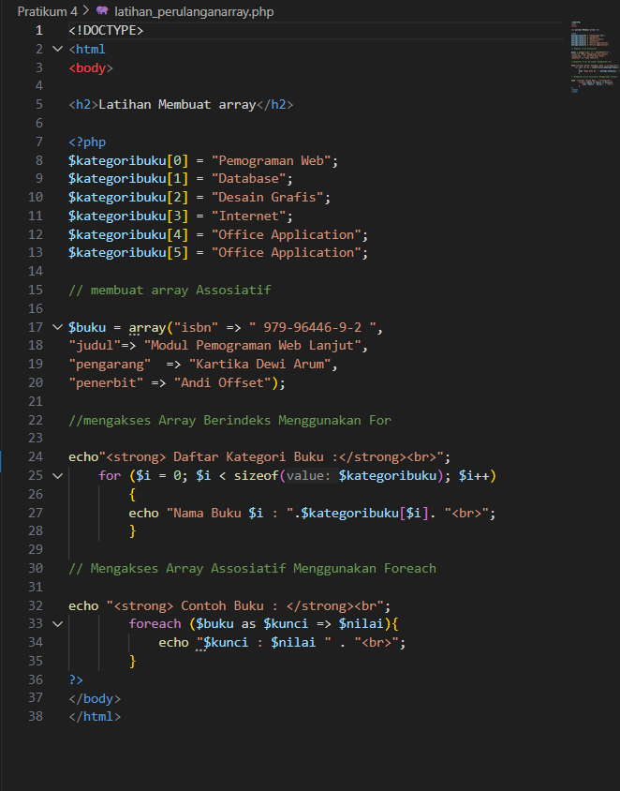

Penjelasan : This is array with looping ,, in this code our objective is to call all the array using loop ,, the code will increment the value of $i everytime it loop and everytime this for is true and every loop the $kategoribuku will show different index or value because in loop sectin $kategoribuku[$i] the index is same with $i

Output :

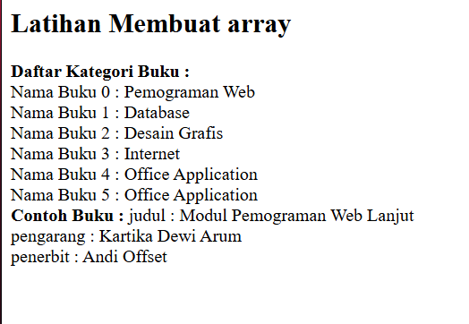

* 1. Screenshot Script dan Output Latihan 4.4.2

Script :

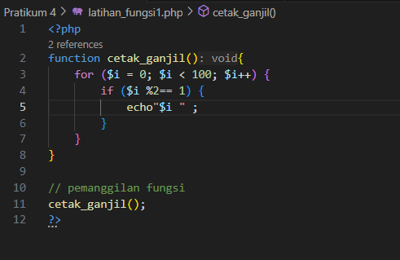

Penjelasan : This is function code that is look like we add some tool to call what we code in this tools like this function is to cetak_ganjil where this code we are using is to make loop section

Output :

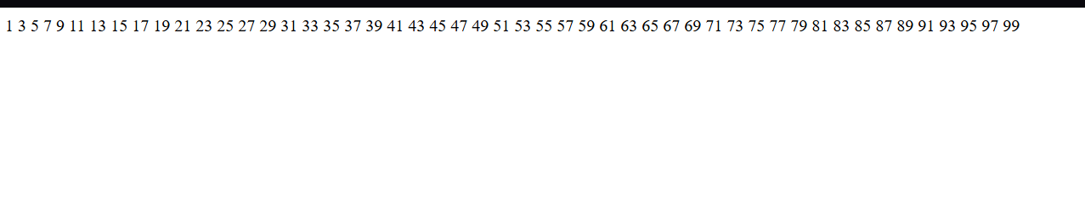

* 1. Screenshot Script dan Output Latihan 4.4.3

Script :

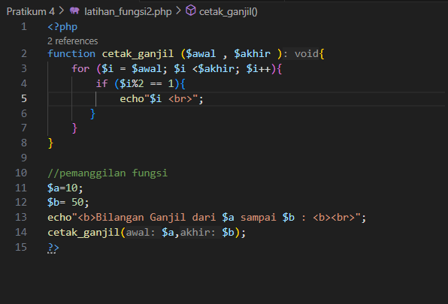

Penjelasan : This is function code that is look like we add some tool to call what we code in this tools like this function is to cetak_ganjil where this code we are using is to make loop section(same with latihan 4.4.2 ) but in this code we add modulo

Output :

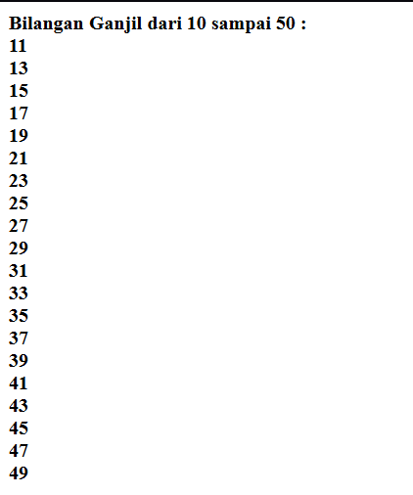

* 1. Screenshot Script dan Output Latihan 4.4.4

Script :

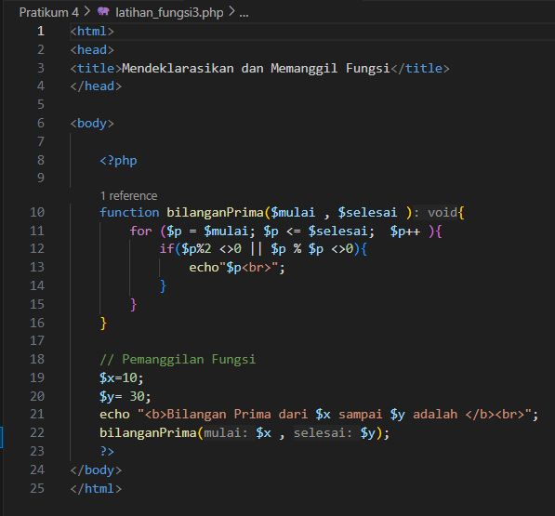

Penjelasan : Function to count primaNumber ,, we are using if else to get number we want

Ouput :

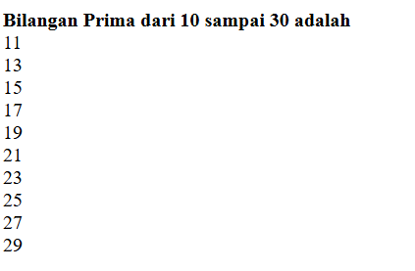

1. Screenshoot Script dan Output Bagian Tugas
2. Screenshot Script, Penjelasan Script, dan Output Latihan 4.5.1

Script :

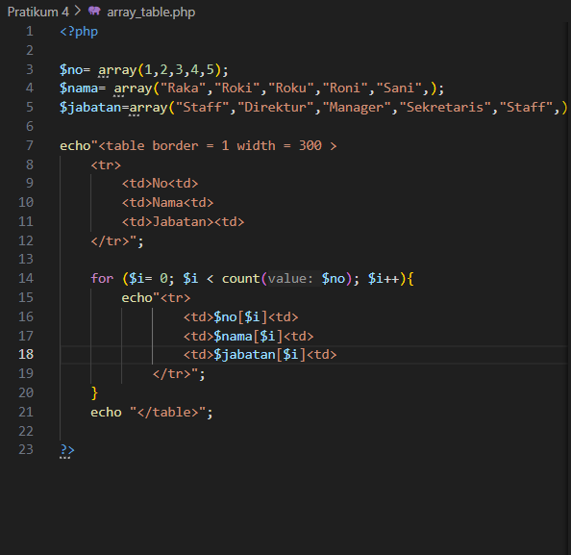

Penjelasan : Array code .. first we make some array variable than make table after that we jump into for loop ,, the loop we echo/display every variable we already make as long as it same with the number of array no.

Output :

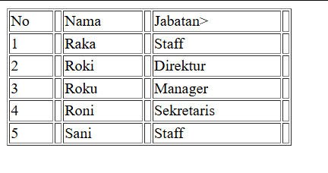

1. Screenshot Script, Penjelasan Script, dan Output Latihan 4.5.2

Script :

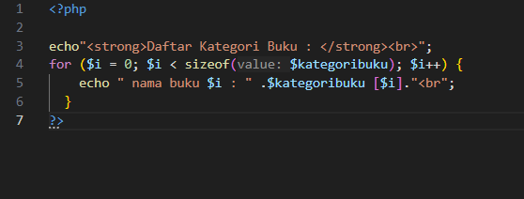

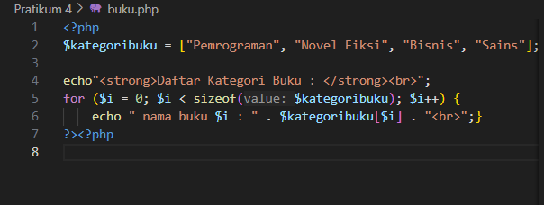

Penjelasan : There is no variable $kategoribuku in first script so the output gonna be error after i make variable the code is fine

2.

Ouput 1 :

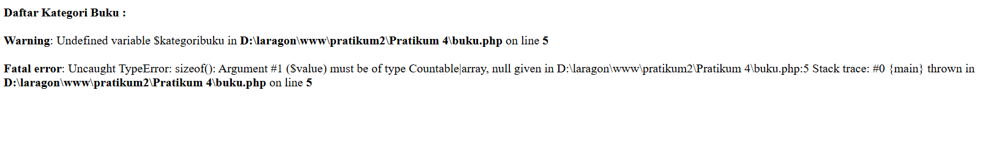

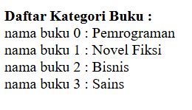

Ouput 2 :

1. Screenshot Script, Penjelasan Script, dan Output Latihan 4.5.3

Script :

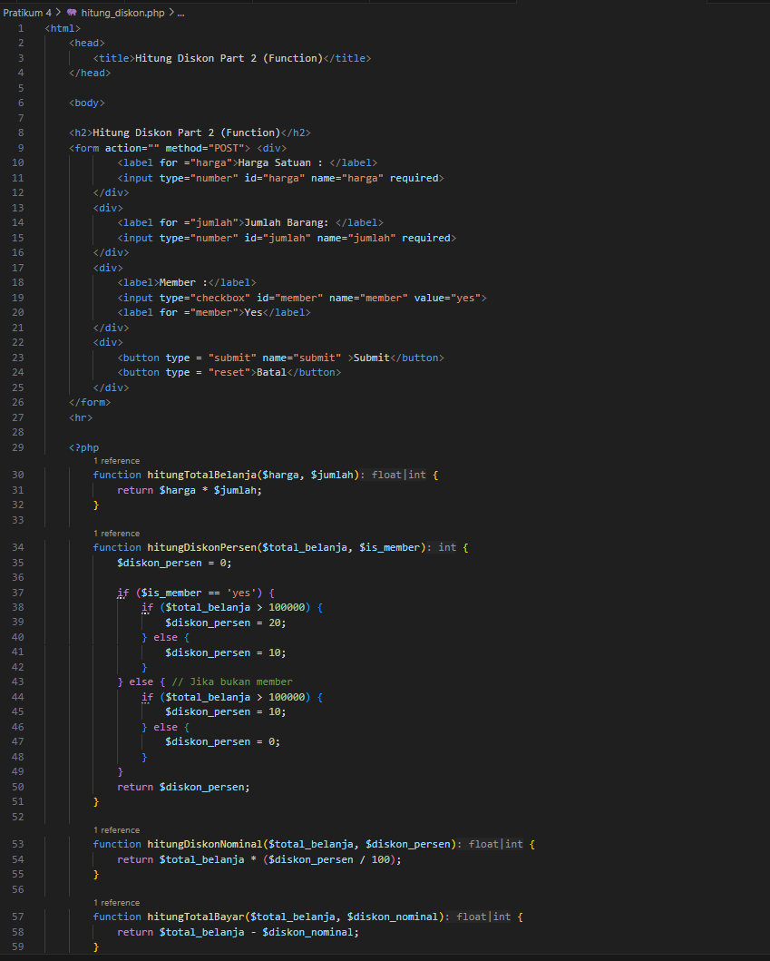

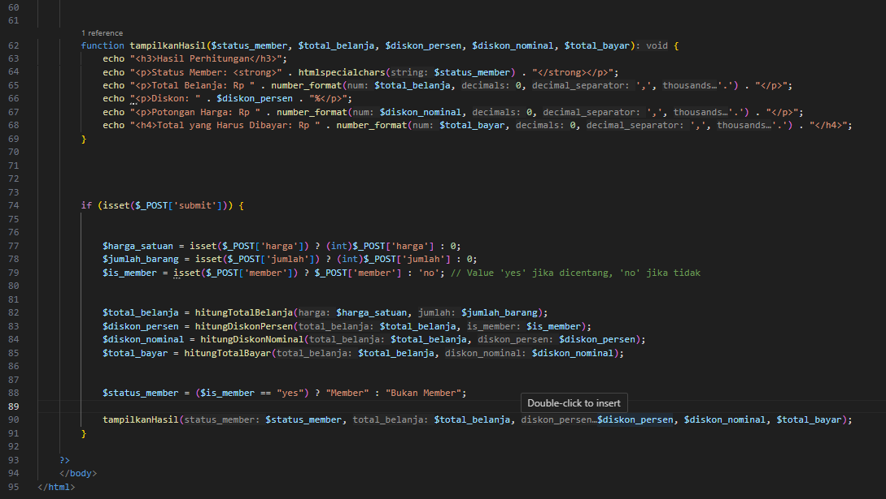

Penjelasan : First we make form type with html then we jump into function total_belanja with *operator on it after it we make diskon function and if else for member or no then we go to another function that is diskon nominal and total bayar with some operator on this function

After this we move into display or echo section in this logic we will call function and output we want to show and last one is submit this one is the most important because in this section we will take the data we need to return or store the data into our variable and function and display every data we already get .

Ouput :

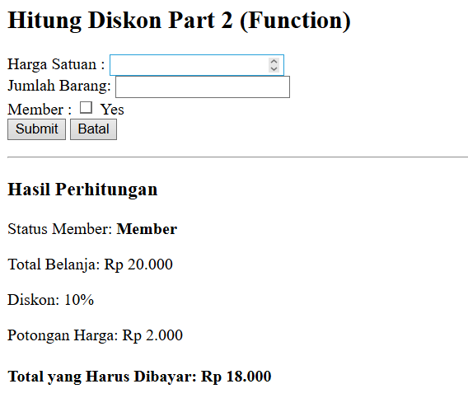

### Eror /Kesulitan

Cukup sulit untuk menggunakan metode function karena terasa cukup tricky

### Daftar Pustaka

### Arief, M. Rudyanto. (2011). Dynamic Web Programming Using PHP and MySQL. Andi

### Publisher: Yogyakarta

### Supporters:

### [2] Madcoms Madiun, (2016). PHP and MySQL Programming for Beginners. Publisher Andi:

### Yogyakarta

### [3] PHP 5 Online Tutorial -http://www.w3schools.com/php

### [4] Arifin, Oki.(2017). Advanced Web Programming Module. Yogyakarta: AMIKOM

### University Yogyakarta.

### [5] Farida, Lilis Dwi. (2017). Advanced Web Programming Module. Yogyakarta: AMIKOM

### University Yogyakarta.